# Lab 3: Electron development tools

In this exercise, you will:

* Set up electron-reload for live reload.
* Set up devtron for debugging.
* Set up electron-is-dev to check if electron is running in development mode.
* Set up electron-log for logging.

1. Check out the Lab-Electron-Development-Tools branch from the remote repository.

git checkout origin/Lab-Electron-Development-Tools

Note: The HEAD of this branch provides the completed code for the entire exercise.

1. Run npm install to ensure all the dependencies have been installed.
2. Create a new local branch for your work based on the "starting point..." commit.

git log --oneline

git checkout <hash for starting point commit>

git checkout -b Lab-Electron-Development-Tools-mine

1. Start the app.

npm run start

## electron-reload

1. Install electron-reload.

npm install --save-dev electron-reload

1. Navigate to main.js at the root level of project and add below code just under the first line. Save your file.

const path = require('path')

require('electron-reload')(__dirname, {

electron: path.join(__dirname, 'node_modules', '.bin', 'electron')

});

1. Restart the app.

npm run start

Note: Now you can check your app for live reload by changing any of the files under assets folder. And you will observe electron app reloads itself. You can read more about its usage by visiting this URL https://www.npmjs.com/package/electron-reload

## devtron

1. Install devtron.

npm install --save-dev devtron

1. Navigate to main.js at the root level of project. Add below lines of code inside createWindow function.

require('devtron').install()

Note: You can add above line of code anywhere inside createWindow function.

1. Restart the app.

npm run start

Note: If you notice there is a line of code inside createWindow function win.webContents.openDevTools(). This opens the default developer tools for electron app. Now in addition to this we will get Devtron installed and ready to be used for more detailed analysis of electron app. You can read more about its usage by visiting this URL https://electronjs.org/devtron

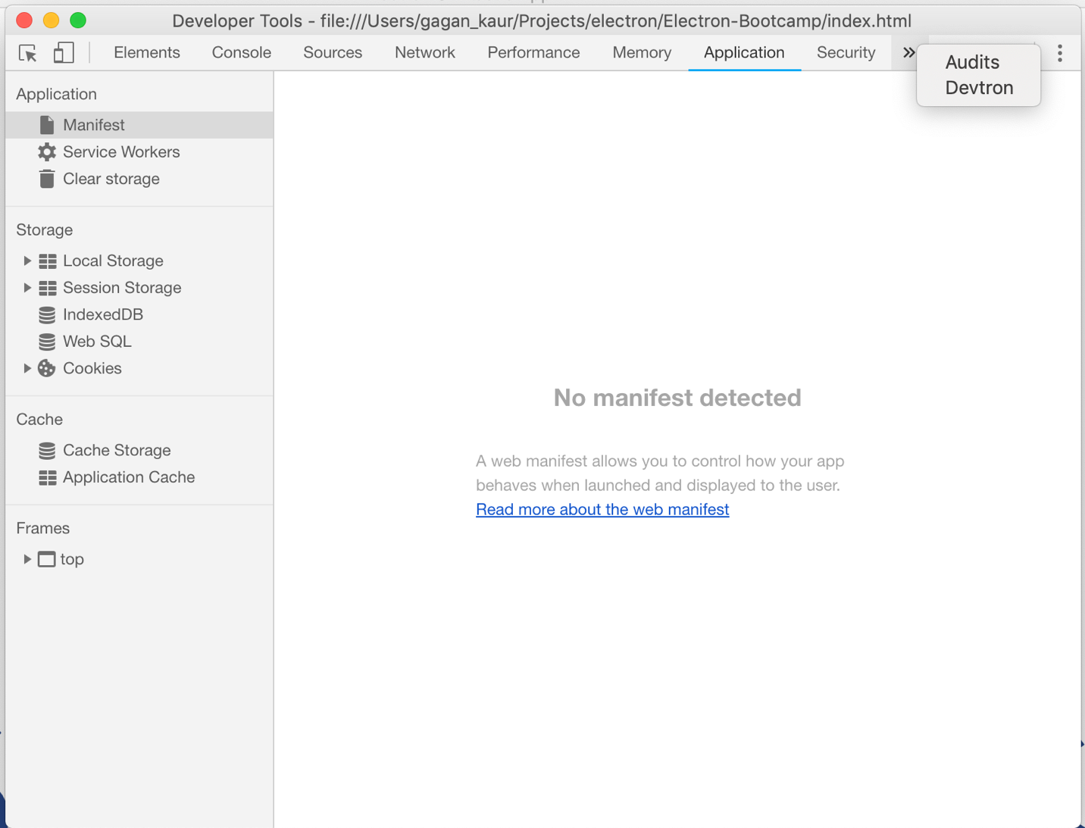

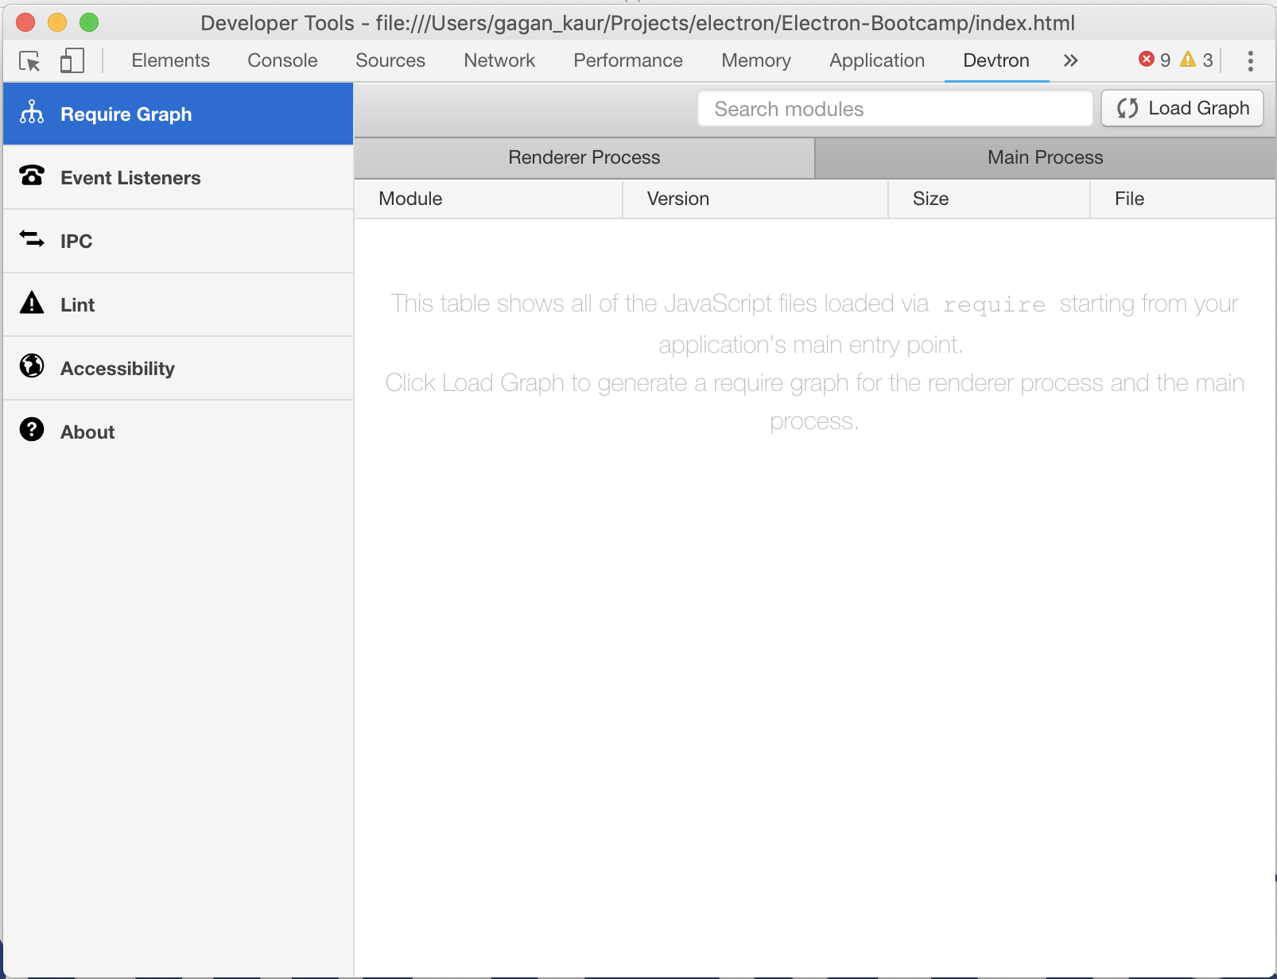

## electron-is-dev

1. Install electron-is-dev.

npm install --save electron-is-dev

1. Navigate to main.js file at the root level of project. Add below line of code at the top level just under first line.

const isDev = require('electron-is-dev');

1. Now you can use isDev variable in the main.js file. This variable can be used to place conditions for code which needs to be run only in development mode.
2. For example, we can place a check in front of live reload code. So, this code does not run in the production version of the app.

if(isDev) {

require('electron-reload')(__dirname, {

electron: path.join(__dirname, 'node_modules', '.bin', 'electron')

});

}

1. Another important usage can be placing a check against dev tools and devtron debugger tool. We do not want the end users to see dev tools open in the production version.

if(isDev) {

// Open the DevTools.

win.webContents.openDevTools()

// Devtron for debugging application

require('devtron').install();

}

Note: You can read more about its usage by visiting this URL https://www.npmjs.com/package/electron-is-dev

## electron-log

1. Install electron-log.

npm install --save electron-log

1. Navigate to main.js file at the root level of project. Add below line of code at the top level just under first line.

const log = require('electron-log');

1. Now you can make use of log variable to place logging information in various parts of your application. For example, we can place a log inside createWindow function.

log.info('window creation');

1. Restart the app.

npm run start

Note: This will generate logs in the terminal where your app is running.

**Debugging Render Processes using Chrome DevTools**

1. You can set breakpoints in a few different ways. First way is using a “debugger;” statement in the code. Open up your code and anywhere in the javascript code you can add the statement

debugger;

1. Another way is setting breakpoints in DevTools by clicking on the line number where you want to set the breakpoint. We will go through both of these below.

Note: To get breakpoints working, the DevToold need to be open first. To open or close ths DevTools use “cmd + option + I” for mac and “f12” or “ctrl + shift + I” for windows. Once the app has started, click on the DevTools window to get focus on it, and refresh the page using “command + r” for mac or “ctrl + r” for windows. Now it should hit the breakpoints and stop. Now you can do any debugging activities like stepping through, seeing values, setting watches, etc.

1. Open assets/js/catalog.js in your code editor. At line 5 add the debugger; statement

debugger;



1. Now if you had electron-reload working, the app should automatically reload itself once you save the change and it should stop on the breakpoint if your DevTools are open. If you don’t have eletron-reload then restart the app using

npm run start

1. Make sure your DevTools are open. Once they are open, click on the window to focus on it and press “cmd + r” for mac or “ctrl + r” for windows to refresh. Now you should hit the breakpoint.
2. To set a breakpoint in the dev tools, first open the sources tab, open the file you wish to set the breakpoint on (catalog.js in this case). If you don’t see the file you can search for it by pressing “cmd + p” for mac or “ctrl + p” for windows and typing in “catalog.js”. Once the file is open click on the line number on the line you wish to set the breakpoint, it will display a blue marker on it once it’s set. Then refresh the app using “cmd + r” or “ctrl + r” and it will stop on the breakpoint.



Errors**:**

1. Remove the debugger statement and add the following line

myVar++

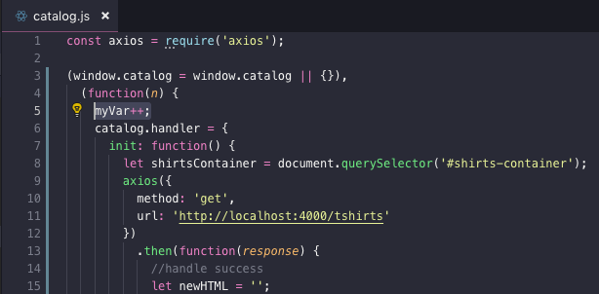

1. Now when you start your app if you go to the console tab in the developer tools you should see the error and some details about it.



1. You can also click on the following button to make the debugger pause on exceptions



1. Now once you have the pause on exceptions selected and you refresh it will pause once it hits the error like so:



**Debugging Main Process using VSCode Debugger**

1. Add a folder named .vscode. Inside that folder add a file named launch.json. Inside .vscode/launch.json add the following code:

{

"version": "0.2.0",

"configurations": [

{

"name": "Debug Main Process",

"type": "node",

"request": "launch",

"cwd": "${workspaceRoot}",

"runtimeExecutable": "${workspaceRoot}/node_modules/.bin/electron",

"windows": {

"runtimeExecutable": "${workspaceRoot}/node_modules/.bin/electron.cmd"

},

"args" : ["."],

"outputCapture": "std"

}

]

}

1. Open the debugger tab and open main.js and set a breakpoint by clicking just to the left of the line number like so:

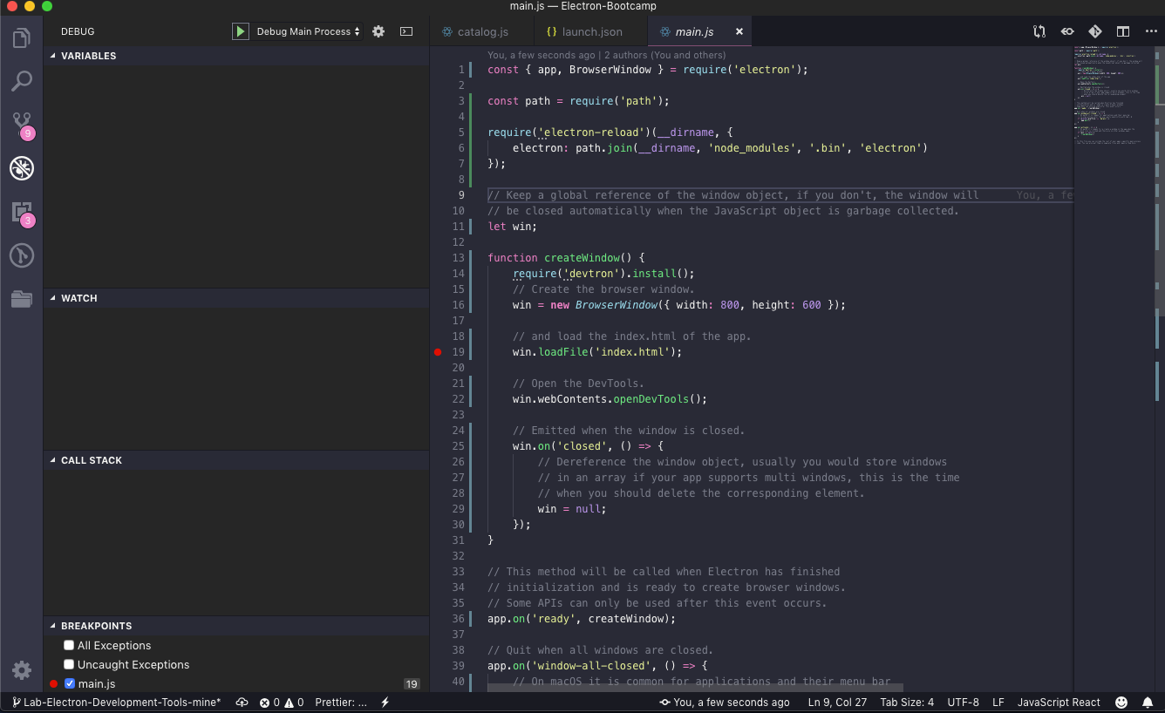

1. You can also use “debugger;” statements like so: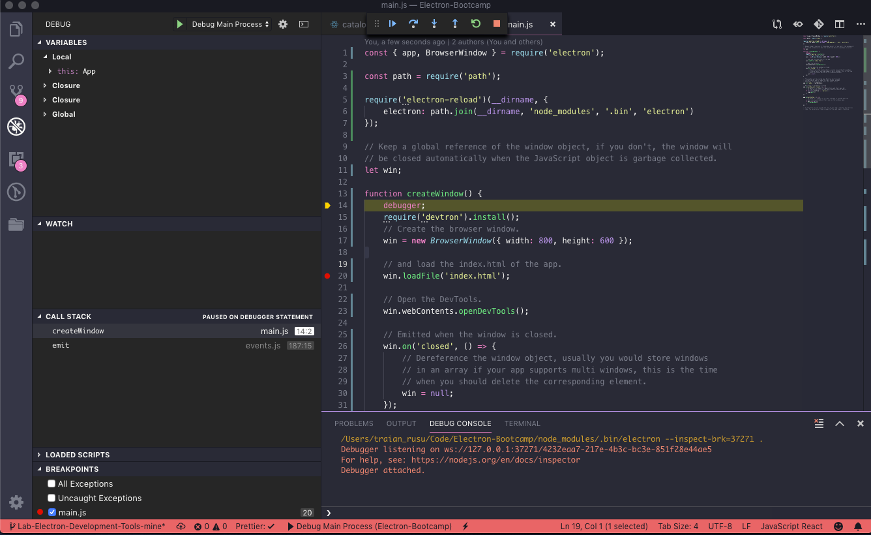
2. Then start debugging by pressing the green play button in the top left and the code will pause on your breakpoint.